Posted 07/16/2012 at 3:38 pm by JAV

Town Hall Building Committee

DRAFT Agenda
Old Library
Thursday July 19, 2012
7:00 PM

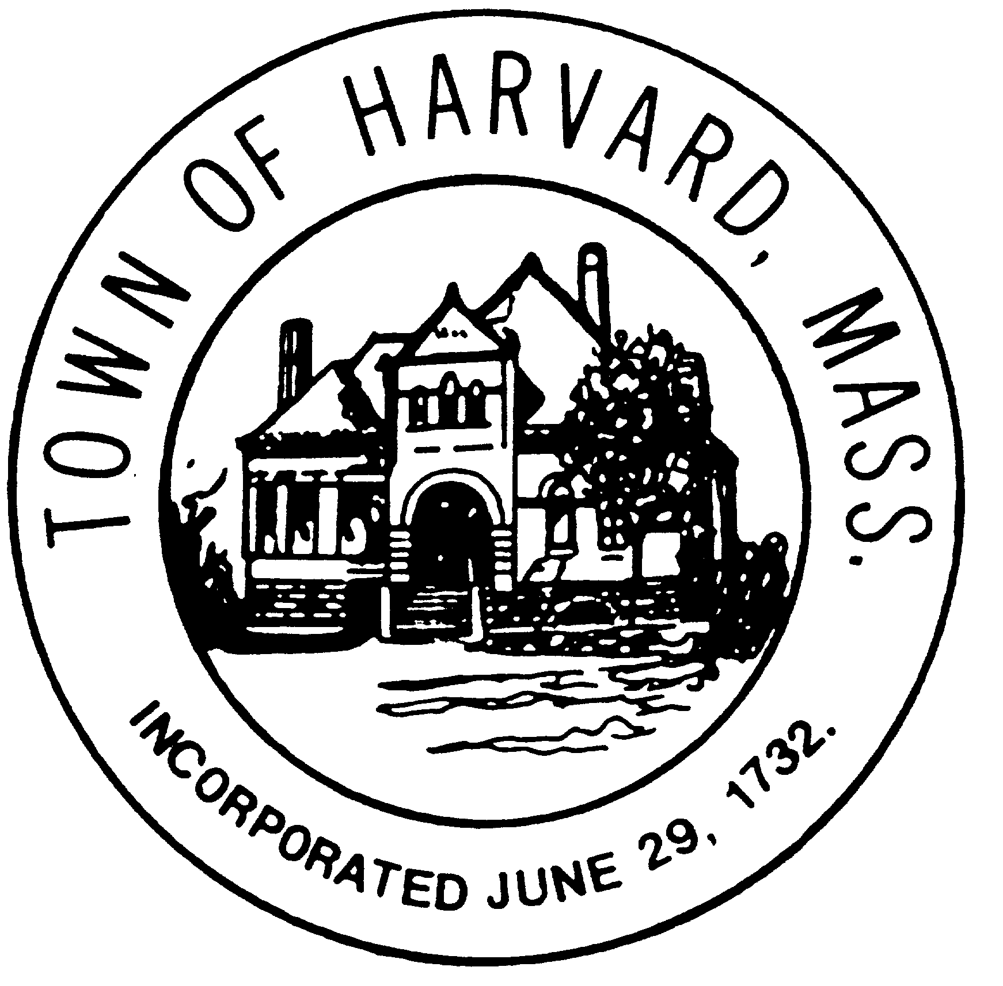
- Approve minutes

- Approve invoices

- Discuss draft agreements with LLB and DTI

- Agenda and date for next meeting(s)

- New business

